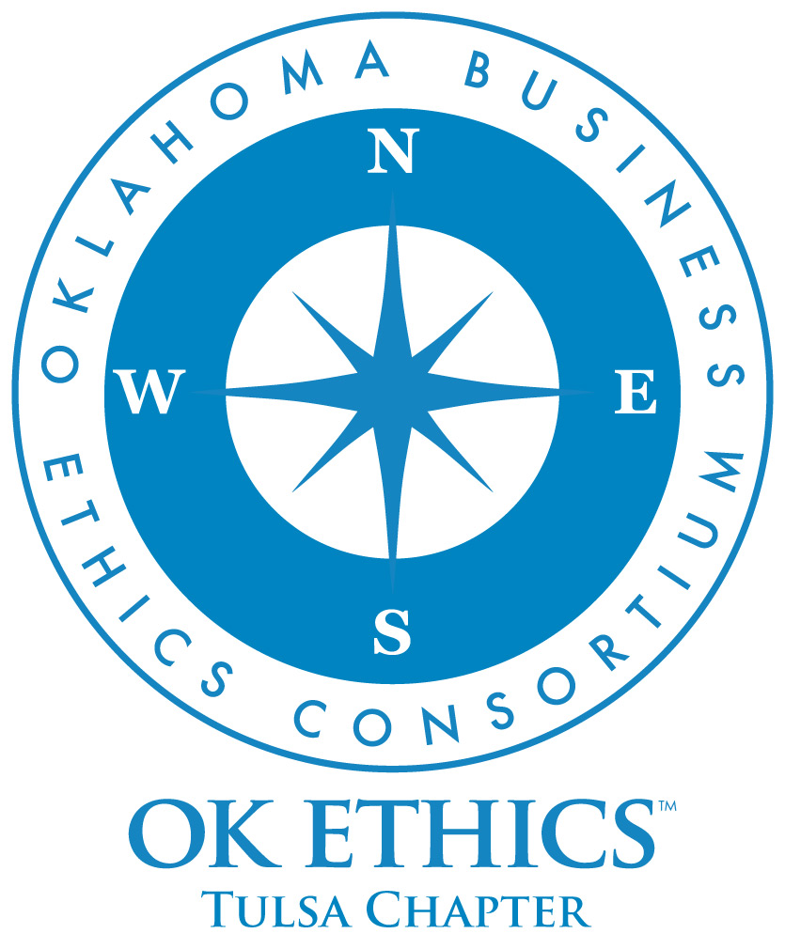
OKLAHOMA BUSINESS
ETHICS CONSORTIUM
Tulsa Chapter Meeting
January 15, 2009

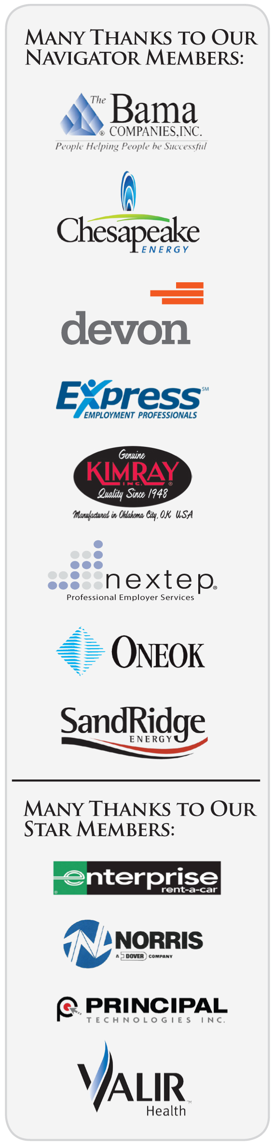
Meeting Agenda

I. Welcome (11:45) John Stancavage, Tulsa Chapter
Legacy Team and Past President

Special thanks to our many volunteers for making this meeting possible.

II. Announcements (11:50)

a. Membership Update Whitney Matthews, Membership
Michael Oonk, Membership

b. OKEthics Compass Awards Rob Martinek, Legacy Team

III. Guiding Principle (11:55) Doyle Paden, Leading Member

IV. Panel Discussion (12:00) John Stancavage

"Economic Meltdown: How Did We Get Into This
Mess and How Do We Get Out?"

Panelists:

Bob Ball, Tulsa Metro Chamber

Paul Cornell, SpiritBank

Fred Russell, Fredric E. Russell Investment Management Co.

David Dyson, business professor, Oral Roberts University

V. Q&A (12:45)

VI. Closing remarks (1:00) John Stancavage

OK ETHICS – Upcoming Events

Tulsa Chapter
- February 26 Robyn Ewing, The Williams Cos. – Core Values & Corporate Responsibility:
100 Years of History
- March 26 Panel Discussion – Generations in the Workplace

OKC Chapter
- February 11 Donna Miller, Executive Resource Center – Good Ethics for Bad Times
- March 11 Clifton Taulbert, The Building Community Institute - "Inside Community."
- April 29 OKEthics Annual Compass Awards, Speaker Sherri Coale, University of Oklahoma

To register for a Tulsa event, or see a list of Oklahoma City or Norman chapter meetings, go to our Web site at www.okethics.org or call 918-808-1086
NOTE: Members of the Oklahoma Business Ethics Consortium frequently share information concerning various issues and developments that may have legal implications. The discussions, commentary, and handouts at Consortium meetings or presentations to other organizations are for general informational purposes only. They cover only some aspects of the subject topic, and do not constitute a complete legal analysis of the topic or how it might apply to any particular set of facts. Before taking any action based on information presented by a Consortium member, participants are encouraged to consult a qualified attorney. The observations and comments of presenters at Consortium meetings and networking are the views and opinions of the presenter and do not constitute the opinion or policies of the Consortium or any of its members. Please note that speakers are advised in advance of OkEthics policy against politicking, preaching, self-promotion and profanity.
OK ETHICS - Membership

Join today – You can make a difference!

Corporate Levels
NAVIGATOR $7,500 Includes 16 memberships; prepaid for all
OkEthics events – including Compass Awards
STAR $5,000 Includes 8 memberships; prepaid for all OkEthics
events – including annual Compass Awards
HORIZON $3,000 Includes 8 prepaid meals at all Tulsa events
LEADING $1,250 Includes 2 prepaid meals at all Tulsa events
FRONTIER $350 Includes 8 memberships; 8 members may attend
events at the discounted member rate

Individual Levels
TRAILBLAZER $500 Includes 1 prepaid meal at all Tulsa events
SCOUT $75 No prepaid meals; may attend events at
the discounted member rate

For more information on membership, go to www.okethics.org

PLEASE HELP US CONTROL COSTS BY LEAVING YOUR NAME TAG HERE!

